Starter Lesson title:

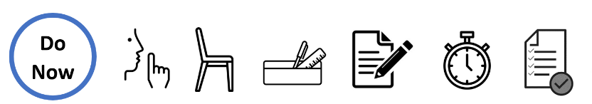
Question |  | Answer | /× | Green pen correction
Last topic
This topic
Mark_____ / 6

Starter Lesson title:

Question |  | Answer | /× | Green pen correction
Last topic
This topic
Mark_____ / 6

